Installation of MAC Case Presentation Code
- Copy MAC_CasePresentation folder to a local shared network from \\phl-fs-sh08\MAC Headquarters\_Model code final.This contains all of the files needed to run the software.
- Install following libraries in Python 3:
  - Open command prompt:
    - Type in: pip install matplotlib
    - Type in: pip install xlrd
- Set up the following folders in a secure shared location (such as O:\MAC Case Presentation)
  - DisplaySettingsLocation
  - MAC PATIENT RECORDS
- Open FilePathSettings.py
  - This can be done with an xml editor such as Notepad++ or IDLE
  - For all file paths in this code, make sure to use forward slash(/), not backward slash(\)
  - Several items need to be specified for your site:
    - InstituteName – change to your location’s name
    - ViconFilesLocation – change to location of Vicon session GCD files
    - DisplaySettingsFileLocation – change to location of DisplaySettingsLocation folder (Ex: O:/MAC Case Presentation/DisplaySettingsLocation)
    - InitalPathForPdf – change to location of MAC PATIENT RECORDS folder
    - UseGreenvilleFolderStructure – set to False unless using Greenville’s folder structure
    - MRorAve
      - Set as ‘MR’ for the default display to be a representative trial
      - Set as ‘Ave’ for the default display to be the average of the selected trials
      - These can be switched between in the display software, this just controls what view is seen as the default.

- Change file path in MAC_CasePresentation.bat
  - Open this batch file in any text editor, then change the path in the second line to your installation of the software. This can use back slashes as normal
    - (Ex: python "O:\MAC Case Presentation\MAC_CasePresentation.py")

Using MAC Case Presentation Software
- Run the program using MAC_CasePresentation.bat
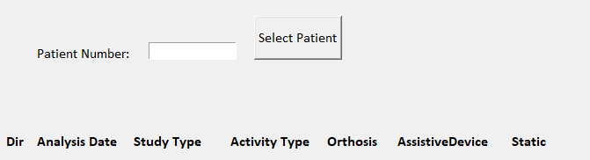
- Enter the patient MRN into the text field, the press “Select Patient”
- If the CasePresentation software has not been used for this patient before, you’ll see the following screen:
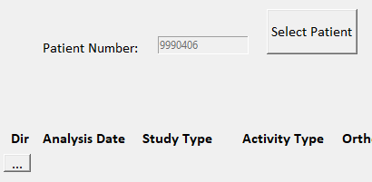
- Select the “…” button under Dir to select the patient’s SESSION folder
  - This selection needs to be the session folder, not the patient folder
- Next, selected the desired Static .py file from the highlighted dropdown list
- Once selected, the date, study type, activity type, and orthoses will autopopulate, depending on the selections in the static file.
  - These can also be edited in the text boxes, as needed
- Select up to 5 walking trials from the L and R drop down menus
  - Only one trial can be selected from each drop down menu
  - The same GCD can be selected in both a left and a right menu
  - MR will default to L1 and R1 if not selected on this screen
    - Can be also be changed on next screen
- After all trials are selected, the “Versions” button can be used to check what version of the SGM code was used to process the GCD files
  - All version numbers found in the selected GCDs will be displayed in the text box below the “Versions” button
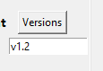
  - If there is more than one version number, the trials should be reprocessed so they are all consistent
- To view more sessions for the same patient, press the “…” button below the active sessions, then choose another SESSION folder, then follow the same steps as before
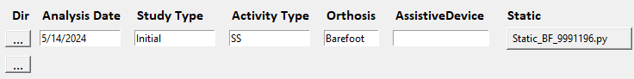
  - It is good practice to enter these sessions into the software chronologically, starting with the oldest session.
- Once all sessions and trials are selected, press the “Save & Proceed” button to view the graphs
  - Once Save & Proceed is selected, the settings and selections are saved and will be pulled in the next time that patient’s record is opened using their MRN.
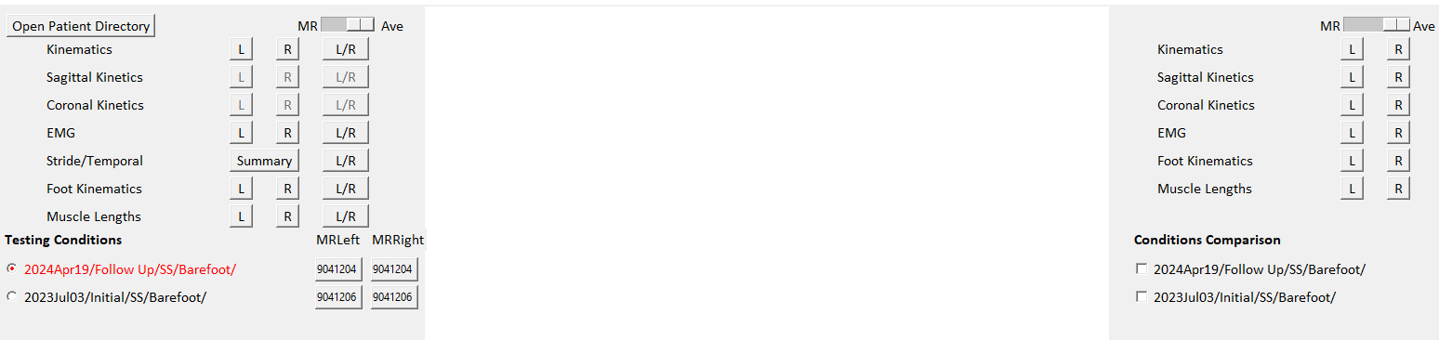
Below is the default view when you first go to the graphs screen:

All of the graphing buttons to the right of the view window deal with comparisons
Select up to three conditions to compare under “Conditions Comparison”
Then use the L and R buttons on the right side of the screen to plot the comparisons
The slider can be used to switch between MR and Ave here as well. Both of the sliders are connected, so any change here will also change the slider on the session portion of the software.
Everything on the left deals with a single session.
Select one session under “Testing Conditions”, then you can view any of the graphs by pressing the L, R, or L/R button next to that graph name.
L and R will show all trials that were selected for that side.
L/R will show the Average and standard deviation of the selected trials, or the representative (MR) trial for each side, depending on which is selected with the slider at the top

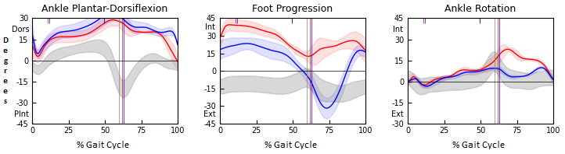
The average graphs plot the average curve as a solid line, with the standard deviations being semi-transparent. No averages are calculated for EMG, so the MR trial will always be used for comparisons.

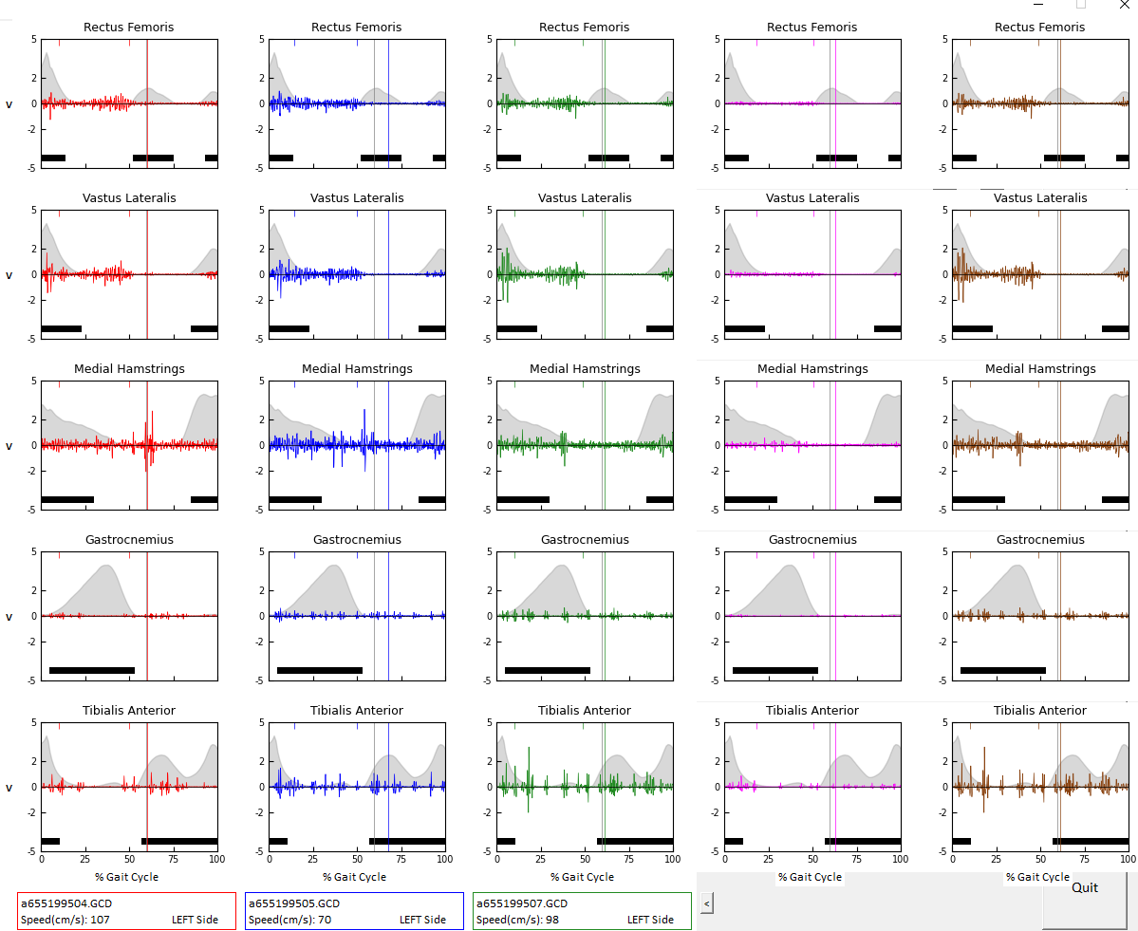
Up to 5 trials can be plotted simultaneously for each side, including EMG.

When plotting 5 EMG trials, the right side of the program window will be covered. To see those buttons, click the “<” button to the right of the trial label boxes. This will collapse the 4th and 5th EMG graphs to reveal the comparison buttons.
Regardless of the number of EMG trials plotted, the DMC can be displayed in the legend. The DMC will only be displayed if the DMC text file already exists in the folder with the gcd files, and will not be calculated by the Case Presentation program. If the DMC is not available, nothing will display in that spot and no error will occur.
The Stride/Temporal button will give the age-matched temporal measurements based on the DOB in the Static .py file. If this date was not entered, the norms may not be properly age matched.
Graph Legends:
When looking at the session plots, there are up to six legend boxes that will appear at the bottom of the page. The gray box in the bottom right will always appear and gives information about the entire session that is selected, including name, study date, and condition. This box will always appear and pulls the name and study date from the static .py file. If those fields were not filled out in the GAS Static, they will remain blank here.
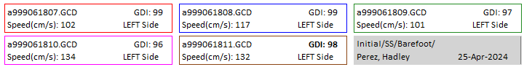
The boxes outlined in color correspond to the graph curves of that same color. These boxes contain: gcd file name, GDI, speed, and which side is being plotted.

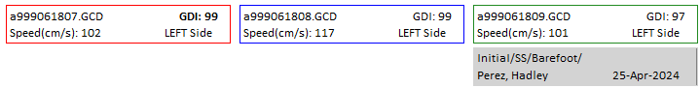
Only the number of boxes necessary to plot the selected trials will be shown. So if only 3 trials are selected, the legend will look like this:
When the L, R, or L/R button is pressed, the code checks if the GDI is available in the gcd. If not, it will automatically calculate it and display that value in the legends. The bolded GDI is the one closest to the median, which could help pick a representative trial.
For comparison plots, whether L/R for the same session or comparisons between session, the legends will contain all of the information needed in each legend, including either the gcd file name or how many trials are used to create the averages:
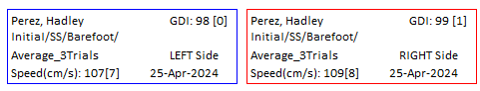
When looking at average plots, the GDI and speed are both listed as Mean [Stdev].

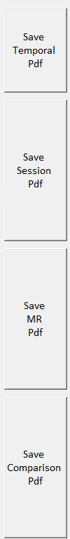
Creating Pdfs:
The pdfs created by this software are not the standard format, which will be created using MoveShelf. These are just options to use for now until MoveShelf is ready and available for all labs.
On the far right of the display, there are 4 save button: Save Temporal Pdf, Save Session Pdf, Save MR Pdf, and Save Comparsion Pdf. All but the Comparison Pdf button create Pdfs using the SESSION data.
The Save Temporal Pdf function will have you select where to save the file (defaulting to the MAC PATIENT RECORDS folder for that patient) then will save the Summary Temporal data into a Pdf
The Save Session Pdf function will prompt what graphs you want to save. Depending on what data is available in the gcds, some boxes will be unchecked, such are kinetics, EMG, or foot kinematics. Others can be unchecked based on user preference. The saved graphs will contain all trials for that side that were selected on the first page of the program. Once these options are selected, the Pdf is saved in the same way as the Temporal data.
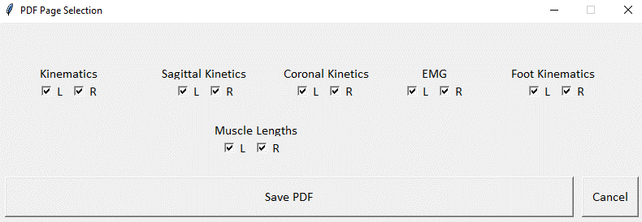
The Save MR Pdf function behaves the same as the Session pdf, but only saves either MR or Average plots for that session, depending on which is selected by the slider.
Lastly, the Save Comparison Pdf function behaves the same as the MR Pdf function, but for the up to three trials selected for comparison using the Conditions Comparison checkboxes.

Troubleshooting:
- If a gcd is not appearing in the list of options in the drop down menus on the first page, use “Save & Proceed” to go to the next page. Then use “Back” to go back to the selection screen. This will reset the list of gcds available to select.
- If your EMG signal is not appearing clearly on the graphs, you may need to amplify the EMG signal in the gcd. This is especially common with wireless systems. There is a python script for this available in \\phl-fs-sh08\MAC Headquarters\_Model code final\Gait\Py3_ShrineGaitModel named “Py3_GCD_AmplifyEMG.py” and a corresponding pipeline in the “Pipeline” folder. Run this for each trial then replot the EMG to see the results better.
- In the legend boxes, a long file name may spill over into the next box. This is something that may be worked on in a future version.
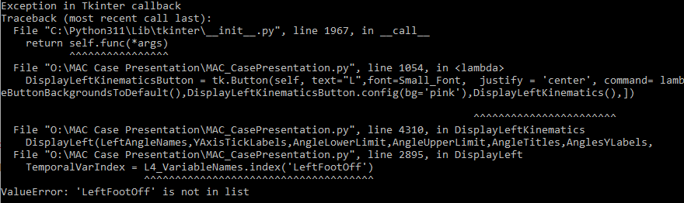
- If no graphs show up when selected, look at the error in command prompt. There should be some indicator of which trial is causing a problem. This is most commonly due to the gcd being empty and needing to be regenerated.
  - In this example, the gcd selected for L4 is empty. After fixing the gcd, the plots showed up as normal

Setting up Shortcut
There is a MAC_CasePresentation shortcut in the folder than can be placed on computer desktops for easier use. First, a few items must be changed:
- Right-click on the shortcut ->Properties
- Under “Shortcut”, change the Target to your local installation of the batch file
- Then change the path for Start in to your local MAC Case Presentation folder
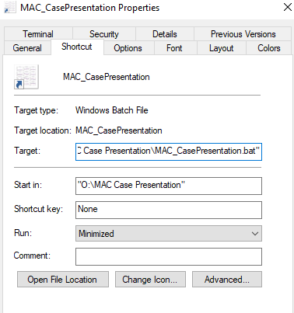
- Click “Change Icon…” then change the path to your local copy of the file “image.ico”
- Once all of these are changed, press Ok to save the changes.
- This shortcut can then be placed on the desktop of any computer that has Python 3 for easy access to the program.

